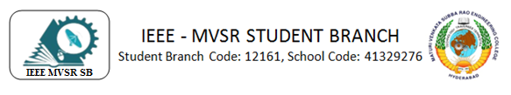
ROBOTIC PROCESS AUTOMATION (RPA) SESSION
The IEEE Computer Society, MVSR Chapter, recently organized a comprehensive three-day session on Robotic Process Automation (RPA), providing attendees with a profound understanding of the subject matter. The session primarily focused on hands-on exploration of the UI Path tool, a leading platform in the field of RPA. The speaker for the session was Guntur Renu, IEEE YP, Chair of Professional activities, and strategies IEEE EduSoC Adhoc Committee.
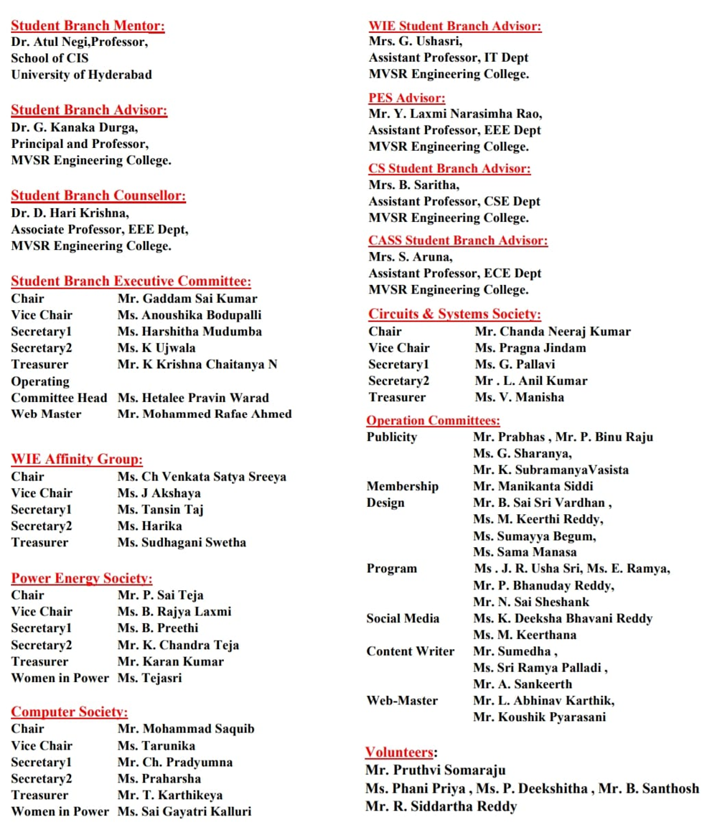

Session Details:
Date:25th-27th November 2023
Timings: 10:30 AM-4:00 PM
No. of Attendees: 54
Speaker
The distinguished speaker for the session was Guntur Renu, serving as the IEEE Young Professionals (YP) Chair of Professional Activities and Strategies, as well as contributing to the IEEE EduSoC Adhoc Committee. With a wealth of experience and expertise, Guntur Renu brought valuable insights to the audience on the topic at hand.
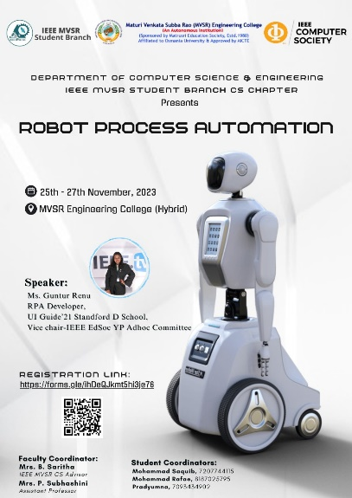

Poster

The IEEE Computer Society, MVSR Chapter, recently organized a comprehensive three-day session on Robotic Process Automation (RPA), providing attendees with a profound understanding of the subject matter. The session primarily focused on hands-on exploration of the UI Path tool, a leading platform in the field of RPA.
Day 1: 25th November
Exploration of RPA Concepts and Career Path
The first day of the session commenced with an insightful overview of RPA, covering its fundamentals, applications, and the evolving landscape in the industry. The speaker, Guntur Renu, delved into the conceptual framework of RPA, elucidating its potential benefits and real-world implementations. The students gained valuable insights into the impact of integration of RPA within business processes and its effect in enhancing efficiency.

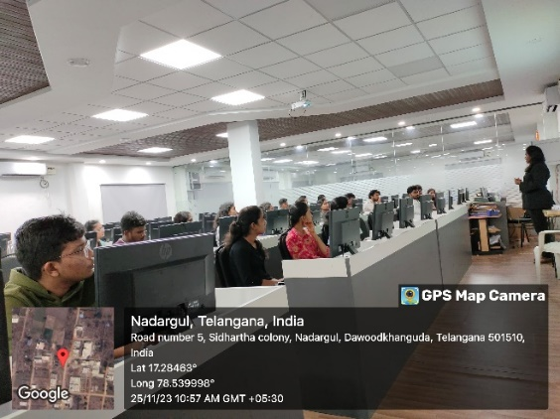

Session on RPA

Following the theoretical foundation, the session seamlessly transitioned into practical demonstrations. Participants were guided through the intricacies of the UI Path tool, exploring its user interface and functionalities. The speaker allocated tasks to the students, who were excited to explore the tool and gain knowledge. The hands-on application and the tasks really helped the students gain a clear understanding of how automation is carried out in different capacities in the industry. After the session, many of the students came up with new ideas of automating repetitive tasks using chatbots and RPA technology. The students worked on automating tasks on a web application.
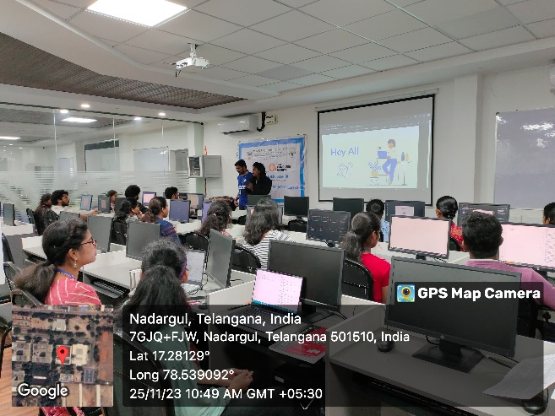

Session on RPA

Day 2: 26th November
Hands-On Workshop
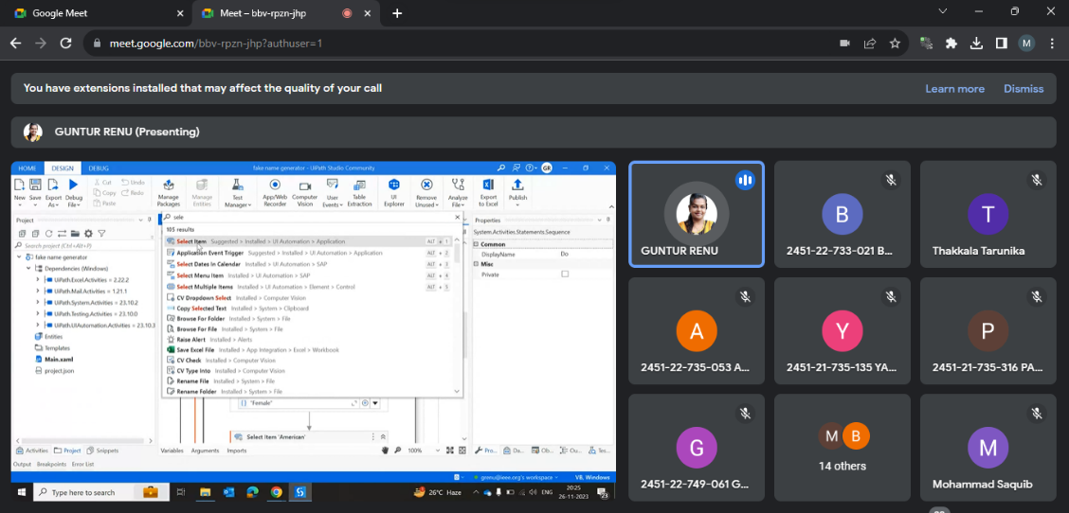
The second day of the RPA session immersed participants in an extensive hands-on workshop utilizing the UI Path tool, facilitating the practical application of their theoretical knowledge. Guided by the speaker, the students actively engaged with the tool to navigate various scenarios, gaining valuable insights into process automation, workflow design, PDF and Excel sheet automation.
Hands-on workshop utilizing the UI Path tool.

Day 3: 27th November
Advanced Topics
The final session on the third day was focused on Excel automation, allowing participants to explore UI Path's capabilities in optimizing tasks related to Excel spreadsheet manipulation, highlighting its potential for boosting efficiency in data-centric workflows. The students also explored PDF automation for automating document-centric tasks such as extracting, manipulating, and managing data from PDF documents under the guidance of the speaker.
The three-day session ended with the IEEE MVSR SB Counsellor, Dr. D Harikrishna appreciating the speaker, Guntur Renu, IEEE YP for guiding the students as an active volunteer of IEEE and IEEE CS coordinators for coordinating the event. He encouraged the students to explore the technology and build upon the knowledge imparted by the speaker. The students were enthusiastic and interested in building chatbots and personal projects to explore the interesting technology.
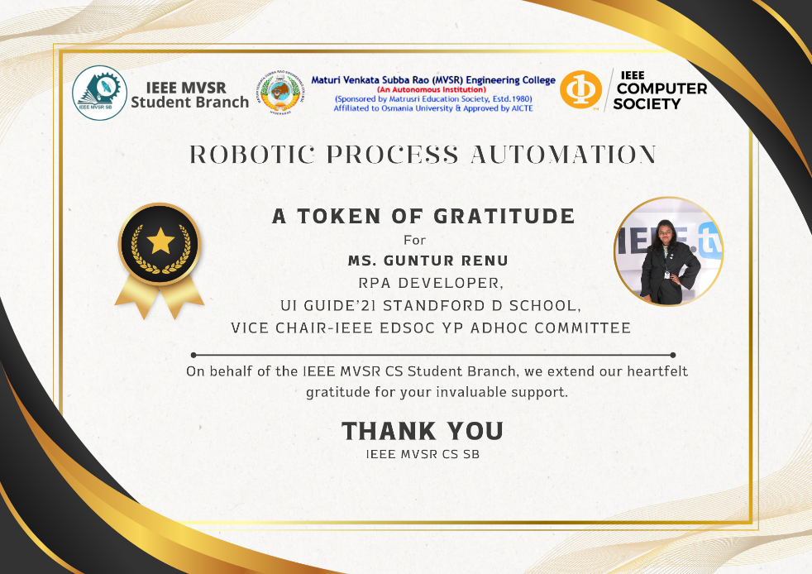
The vote of thanks was given by IEEE CS Chair Mohammmad Saquib, who thanked the speaker Guntur Renu for taking out the time to guide the students. He thanked IEEE MVSR SB Counsellor, Dr. D Harikrishna, and IEEE MVSR CS Advisor Mrs. B Saritha and Mrs. P Subhashini for encouraging and supporting IEEE MVSR CS in organizing the events and the volunteers and attendees for making the 3-day session a great success filled with learning and development.
Memento presented to speaker.
List of Attendees:
S.NO | Name of the Participant | Roll Number | IEEE ID
1. | Dr. D. Harikrishna | Faculty | 90436180
2. | Mrs. B. Saritha | Faculty | 95070854
3. | Mohammad Saquib | 2451-20-733-132 | 97496648
4. | Mohammed Rafae Ahmed | 2451-20-733-162 | 97470002
5. | Thakkala Tarunika | 2451-20-733-149 | 97508555
6. | Koushik Pyarasani | 2451-21-733-083 | 99228518
7. | Chacham Pradyumna | 2451-21-733-066 | 99228779
8. | Dhruv Reddy G | 2451-22-748-058
9. | Joshi Vamshi Krishna | 2451-22-749-037
10. | Gillella Rahul | 2451-22-749-025
11. | Gade Nikitha | 2451-22-749-061
12. | Tanvi | 2451-22-748-012
13. | Gaddam Ruthvika | 2451-22-748-011
14. | Harshita Bompalli | 2451-22-733-021
15. | Saireddy Manasvi | 2451-22-733-061
16. | Aligeti Sri Charitha | 2451-22-748-015
17. | Ampalla Sravanthi | 2451-22-733-301
18. | Andoju Laxmi Prasanna | 2451-22-733-313
19. | Modugu Sreeja | 2451-22-749-010
20. | Masagouni Akshitha | 2451-22-735-024
21. | Lakshith Reddy | 2451-22-735-059
22. | Jayanth Reddy | 2451-22-735-055
23. | Athota Yamini | 2451-22-735-048
24. | Prathi Manas Viswanauth | 2451-22-735-036
25. | Bukka Karthikeyan | 2451-22-733-150
26. | Akshit Darla | 2451-22-735-053
27. | Kondru Raja Nakshathra | 2451-22-733-025
28. | A Sanjay Kumar | 2451-22-748-016
29. | S. Lahari | 2451-22-733-310
30. | Manthapuram Krishna Chaitanya | 2451-22-735-011
31. | P. Satya Sai Shashank | 2451-22-735-031
32. | Mohammed Muqueed Uddin | 2451-22-735-054
33. | Athmakuri Sairam | 2451-22-735-043
34. | Praharsha | 2451-21-737-170
35. | G. Harsha | 2451-22-733-143
36. | M. Abishek | 2451-22-733-177
37. | K. Rajesh | 2451-22-733-172
38. | Annapurna R | 2451-22-737-168
39. | Koti Sri Lasya | 2451-22-733-036
40. | K. Harhsa Vardhan | 2451-22-733-143
41. | G. Vikas | 2451-22-735-056
42. | Ch. Sujith Kumar | 2451-22-749-029
43. | Yallabandi Lohitha | 2451-21-735-135
44. | Suha Taskeen | 2451-21-735-173
45. | P. Usha | 2451-21-735-316
46. | Pilli Sabitha | 2451-21-735-171
47. | Batuvula Srikanya | 2451-21-733-308
48. | Velimeneti Preethi Reddy | 2451-22-733-098
49. | Shoaib Alam | 2451-22-748-020
50. | Bhoomika Ramchandani | 2451-22-749-055
51. | Kartaverya
52. | Tulaja Sonte | 2451-22-672-023
53. | Nandagiri Akhila | 2451-22-748-018
54. | Prameela | 2451-21-733-314

Reported by
IEEE MVSR SB

